# Lab 14: Component Communication through Multiple Levels

## Objectives

*  In a child component, accept a function as a prop and invoke it and pass a parameter
*  At the next level in the component hierarchy, accept a function as a prop and invoke it
*  In a parent component, implement a function and pass it as a prop to a child component

## Steps

### In a child component, accept a function as a prop and invoke it and pass a parameter

1. **Open** the **file** src\projects\ProjectForm.js.
2. To the propTypes, **add** an onSave function.

#### src\projects\ProjectForm.js

1. **Create an event handler function handleSubmit to handle the submission of the form.**

The function should prevent the default behavior of the browser to post to the server and then invoke the function passed into the onSave prop and pass a new Project that you create inline for now with just a name as shown below.

Update the <form> tag in the render method to invoke handleSubmit and pass the SyntheticEvent object representing the DOM submit event.

#### src\projects\ProjectForm.js

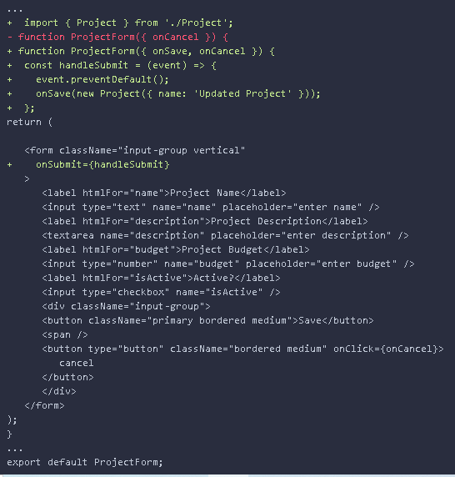

### At the next level in the component hierarchy, accept a function as a prop and invoke it

1. **Open** the **file** src\projects\ProjectList.js.
2. To the propTypes, **add** an onSave **event handler**.

#### src\projects\ProjectList.js

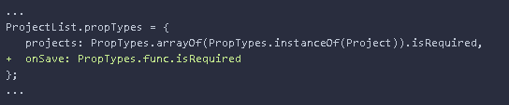

1. **Update** the <ProjectForm> component tag to **handle** a onSave event and have it **invoke** the function passed into the onSave prop.

#### src\projects\ProjectList.js

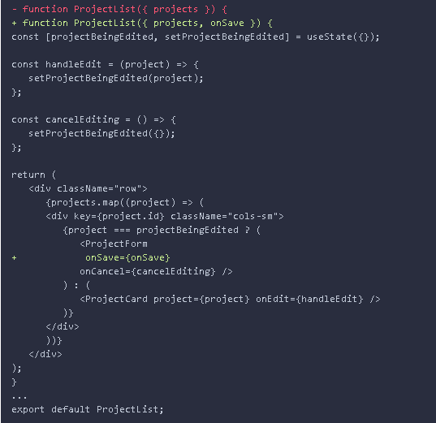

### In a parent component, implement a function and pass it as a prop to a child component

1. In the file src\projects\ProjectsPage.js:
   1. **Add** a saveProject**event handler** that takes a project to ProjectPage and console.log's the project out.
   2. **Wire** up the **onSave** **event** of the <ProjectList /> component rendered in the ProjectPage to the saveProject event handler.

#### src\projects\ProjectsPage.js

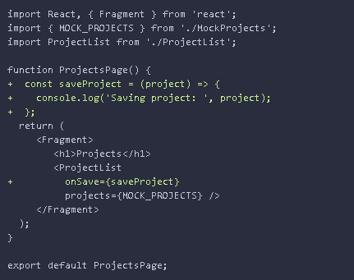

1. **Verify** the **application** is working by following these steps:
   1. **Open** the application in your browser and refresh the page.
   2. **Open** the Chrome DevTools to the console (F12 or fn+F12 on laptop).
   3. **Click** the **edit** button for a project.
   4. **Click** the **save** button on the form.
   5. **Verify** the updated project is logged to the Chrome DevTools console.

Note that the ProjectCard info will not be updated at this point.

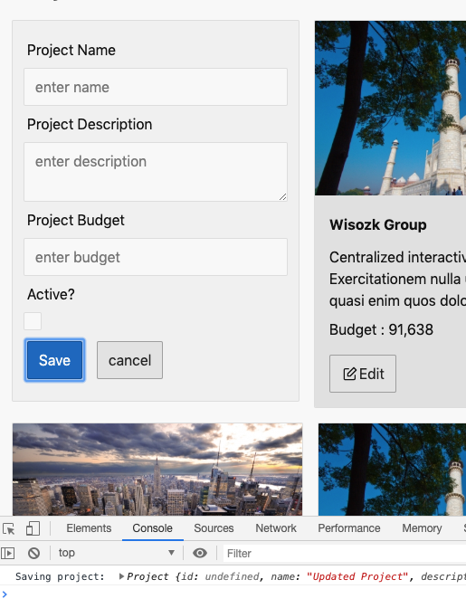

### ✔ You have completed Lab 14